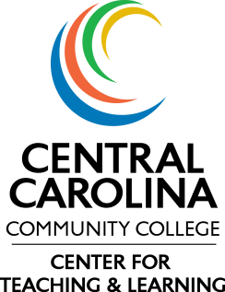 | 2014-2015 Center for Teaching and Learning Grants  Project/Activity Evaluation

Name of Project/Activity:
Participants:
Date(s) of Project/Activity:
- Did this project or activity improve or enhance your instruction? (Agree/Disagree)
If agree, please explain how your instruction has improved or been enhanced.

- How did this project or activity impact student learning?

Please share information and materials acquired through the project or activity. Send to Amanda Carter (abcarter@cccc.edu). Thank you for participating in the Center for Teaching & Learning Grants.

